John Michael Go
Career Entry Level Java Programming
Date: Jan. 16, 2013

DAY 4

Program Name: Dots

Objective: Program countdowns from 10 to 1 before displaying a message.

Algorithm:

- Program countdowns from 10 to 1 before displaying a message.

Pseudocode:

public class Dots{

public static void main(String[] args)
{

for (int x = 10; x > 0; x--)
{
System.out.print (x);

for (int y = 1; y <= 10; y++)
{
System.out.print ("");

int z = 1;
while ( z <= 100000000)
z++;

System.out.print (".");

}

System.out.println ("\n");

}

System.out.println (" Happy New Year !");

}

}

Screenshot:

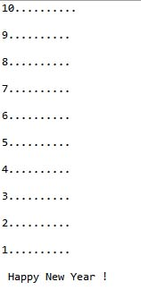

Flowchart:

